Name : Fariha Arai

AF ID : AF0443236

Lab 2

**1. Calculate the multiplication and sum of two numbers.**

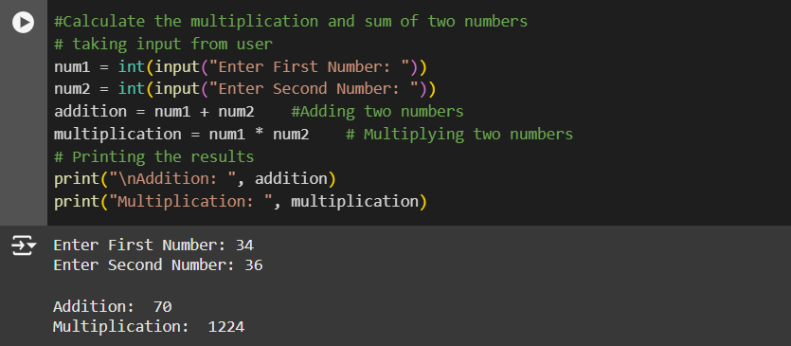

**2. Declare two variables and print that which variable is largest using ternary operators.**

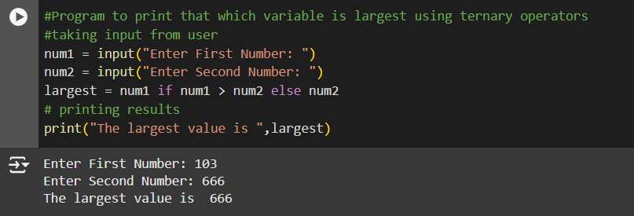

**3. Python program to convert the temperature in degree centigrade to Fahrenheit.**

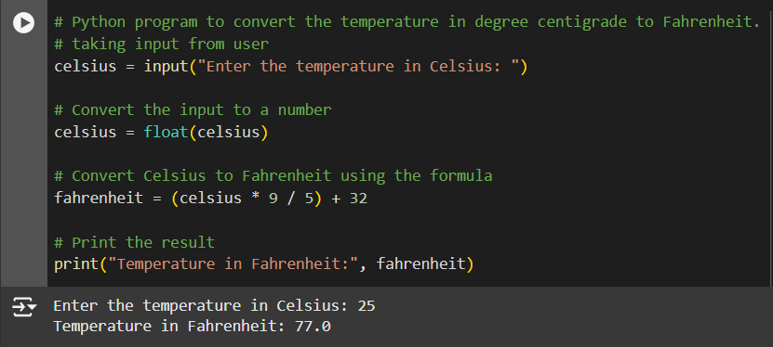

**4. Python program to find the area of a triangle whose sides are given.**

